FOR IMMEDIATE RELEASE
Media Contact: Wendy Winters, wendy@cooc.com
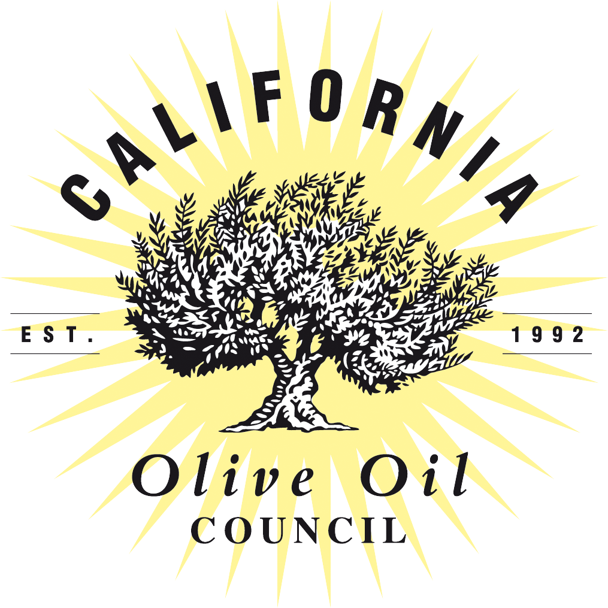

California Olive Oil Council Announces Recipients of Extra Virgin Olive Oil Competition at Annual Conference
Event Honors Best of Show, Gold and Silver, and Pioneer of the Year Award Winners, Features Valuable Content and Trade Show

March 28, 2019, Monterey, Calif.— The California Olive Oil Council (COOC) held its annual conference and trade show on March 22-23 in Monterey in which it honored award recipients of the 11th Annual California Olive Oil Council Extra Virgin Olive Oil Competition. The conference also featured valuable content sessions covering branding, research, sustainability, legislative updates, sensory sessions, and workshops. Simultaneously, the event trade show showcased 21 service providers and sponsors ranging from those selling bulk olive oil, to packaging and glass manufacturers, as well as equipment suppliers.

This year’s Olive Oil Competition resulted in Gold and Silver medal winners as well as Best of Show. Winner in each of the categories included:

Best of Show
- Marciano Estate: Organic
- Rio Bravo Ranch - Coratina
- Wild Groves: Ascolano

Gold Medal Winners
- Boccabella Farms: Arbequina
- Boccabella Farms: Lucca
- Burroughs Family Orchards: Organic Family Blend
- Fandango Olive Oil: Organic Fiesta
- Grumpy Goats Farm: Organic Picual
- Marciano Estate: Organic
- Rancho Azul y Oro: Estate
- Rio Bravo Ranch: Coratina
- Tres Osos Olive Oil – Organic Robust
- Lacrime di San Miguel – Nocellara del Belice
- Wild Groves: Ascolano

Silver Medal Winners
- Boccabella Farms: Field Blend
- Boccabella Farms: Winemakers Blend
- Bondolio Olive Oil: Estate Blend
- California Olive Ranch: Arbosana
- Campodonico Olive Farm
- Ciarlo Fruit and Nut: The ‘Hood
- ENZO Olive Oil Company: Organic Bold
- ENZO Olive Oil Company: Organic Delicate
- Kiler Ridge Olive Farm: Nocellara del Belice
- Kiler Ridge Olive Farm: Tuscan
- Lone Oak Olive Oil
- Milagros Olive Advisor
- Olivaia’s OLA: Block X Blend
- Olivaia’s OLA: Estate Sevillano
- Oliveto Ranch: Tuscan
- Organic Roots Olive Oil: Koroneiki
- Rio Bravo Ranch: Picual
- Rio Bravo Ranch: Miller’s Reserve Blend
- San Miguel Olive Farm: Tuscan Gold Supremo
- Spanish Oaks Ranch: Reserve

Using the Mario Solinas Assessment, COOC judges from the organization’s tasting panel, assessed the olive oils. The Mario Solinas Assessment, a specifically designed method for judging olive oils, is used around the world by trained panels to establish uniformity in scoring.

COOC Executive Director Patricia Darragh, “We are grateful to our members who work diligently to craft a well-balanced, delicious extra virgin olive oil. They deserve this recognition for their hard work and adherence to best practices. We encourage consumers and retailers to continue their support of 100% California certified extra virgin olive oil.

A reception and awards dinner capped the meetings with Carol Firenze, an educator, author (“The Passionate Olive”) and tireless advocate for California olive oil, receiving the Pioneer Award.

About the California Olive Oil Council and its Seal Certification
Founded in 1992, the California Olive Oil Council (COOC) is a non-profit trade and marketing association whose purpose is to promote the growing of olives and the production of fresh, high-quality extra virgin olive oil in California. The COOC represents more than 90% of olive oil production in the state with a membership of 400 growers, producers, and supporting members from the retail and service industries. The organization supports certified olive oil standards and provides grower, producer and consumer education. Through its Seal Certification program, the COOC helps everyone from home chefs to restaurants find guaranteed extra virgin olive oils for their kitchens. For more information, visit cooc.com.

###

